Library New Normal Simple SOP
You follow simple rules for us, we do our work for you
- At the Library entrance you need to:
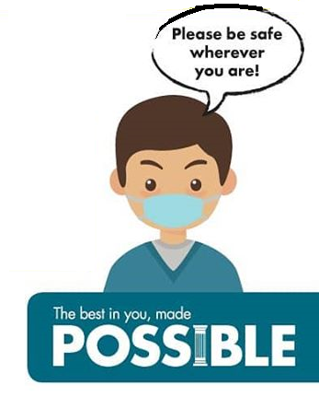
  - Show your VALID student ID tag for barcode scanning – if you are not a Library member, you may now register
  - Your student ID must be active (not expired) & need to be shown in physical, not in phone etc.
- Keep yourself safe in the library by observing the followings:
  - Wear your face mask when needed
  - Maintain appropriate at least 1 meter away of social distancing
  - No group sitting for discussion
  - No gathering in washroom or Library space
  - No eating of food to ensure your own study ambiance is clean & tidy
  - No talking loudly as to respect other Library users

